**Exp 7 Design a Programmable Digital Data Display system**

**CIRCUIT DIAGRAM**

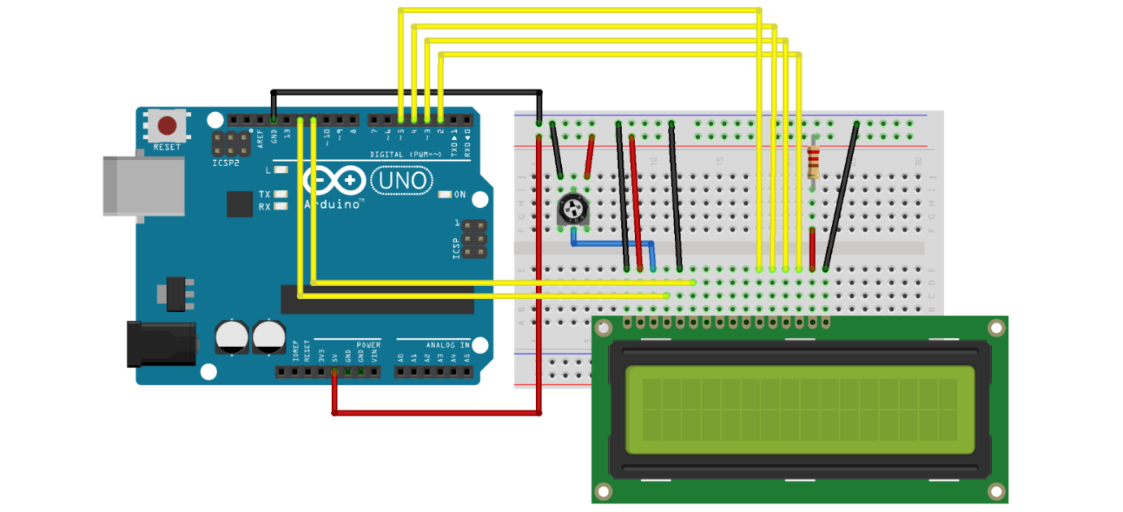

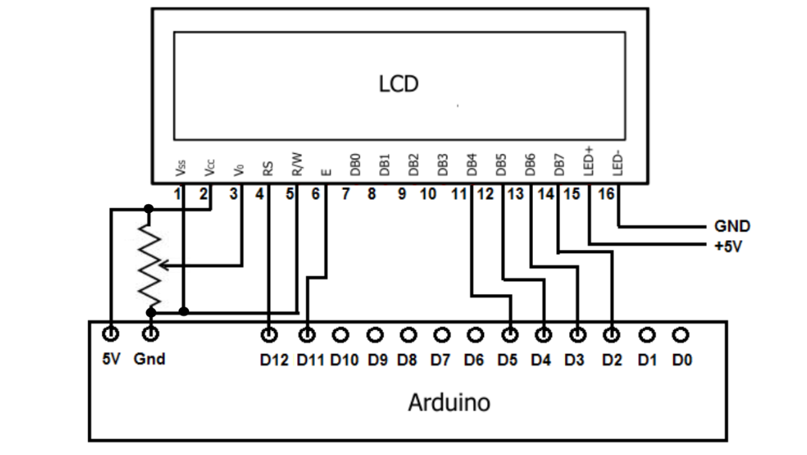

**THEORY**

**CONCEPT USED**

LCD is used with Arduino in such a way that whatever written in a code can be displayed directly on to the LCD. Only connections with Arduino will help doing all this.

**LEARNING AND OBSERVATION**

LCD used with Arduino help in displaying things directly whenever code is entered.

**PROBLEM AND TROUBLESHOOTING**

While making the circuit, connection are needed to be maintained corrected. Problem which I faced while performing is that , connection are not made correctly which lead to an error.

**PRECAUTIONS**

1. Connections must be tight and correct.
2. Coding must be right.
3. Components used must be working properly.
4. Before uploading the program , Arduino must be connected.
5. LCD must be provided correct connections.

**LEARNING OUTCOMES**

Displaying LCD make it easy to make displaying board to use advertisement or anything. Working is when known make it easy for everyone to make use of it.